Experiment 2

:Measurement of g

Name: Jonathan Goh

UID: 404901382

Date Performed: 4/25/18

Lab Section: Wednesday 8 a.m.

TA: She, Zhenyu

Partner: Daniel Schwartz

**Worksheet:**

1. Derivation

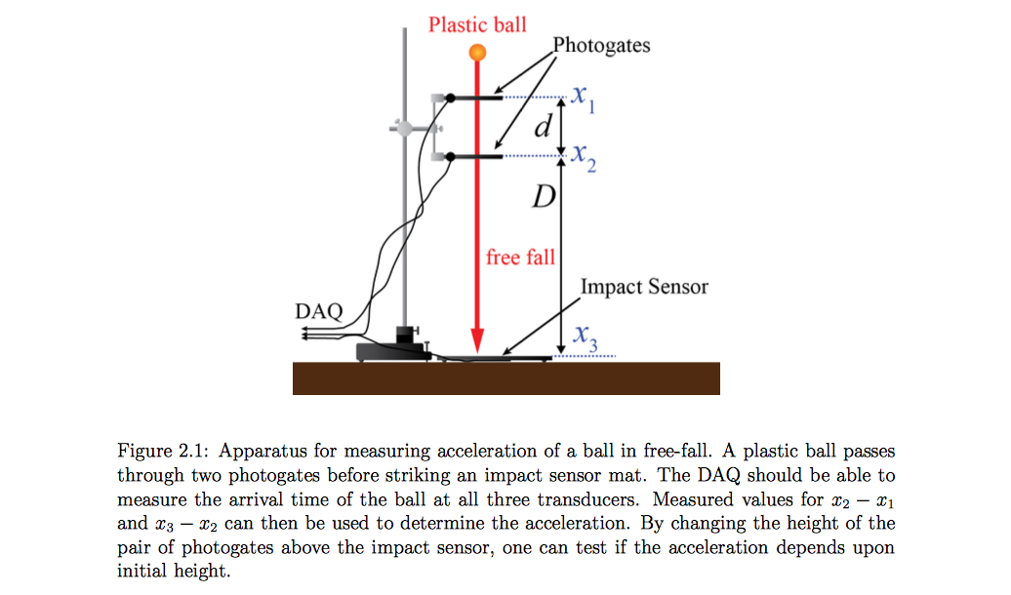

As stated in the lab manual, $T{}_{1}$ and $T{}_{2}$ were gathered from the time between the two photogates and the time between the second photogate and the impact sensor. Due to this fact we derive the equation for g by using the time when the object was midway between $(x{}_{1},x{}_{2})$ and $(x{}_{2},x{}_{3})$. Since g is an acceleration, we can use the relationship that the change in velocity is equal to the acceleration.

$v{}_{d}=$ $d/T{}_{1}$**(The average velocity over distance $d$)**

$v{}_{D}=$ $D/T{}_{2}$**(The average velocity over distance $D$)**

$T{}_{1}/2$**(Time at halfway between $x{}_{1} and x{}_{2}$)**

$T{}_{2}/2$**(Time at halfway between $x{}_{2} and x{}_{3}$)**

$(T{}_{2}+T{}_{1})/2$**(Time between the midpoints of the two regions)**

Using the relationship that acceleration equals change in velocity:

$g=\frac{v{}_{D}-v{}_{d}}{(T{}_{2}+T{}_{1})/2}$

Then substitute velocity variables:

$g=\frac{D/T{}_{2}-d/T{}_{1}}{(T{}_{2}+T{}_{1})/2} → g=\frac{2}{(T{}_{2}+T{}_{1})}⋅(\frac{D}{T{}_{2}}-\frac{d}{T{}_{1}})$

1. Plots

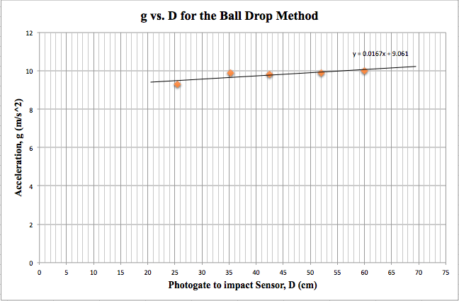

**Do you expect that g should depend upon D? Briefly discuss this and what your data tell you. Can you find a way to quantitatively confirm or rule out a linear dependence on D?**

I would not expect the magnitude of gravity to vary due to the value of D. As seen in the graph, the slope of the line of best fit is 0.0167 which is exceptionally close to a slope of 0. A zero slope would indicate a constant value of acceleration across all values of D. The slight slope of the trendline can be attributed to errors and uncertainties in the data measurements. As a result, we conclude that g is not dependent on D.

Below are four trials of the Photogate Comb Method:

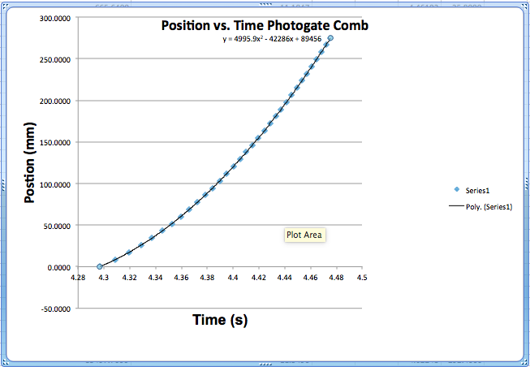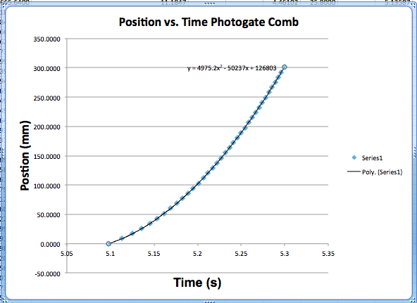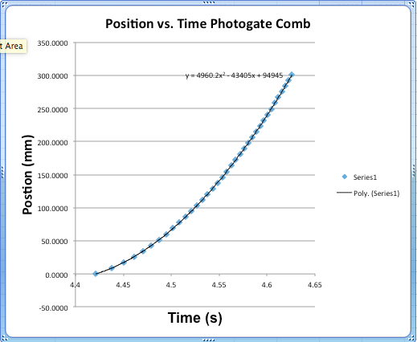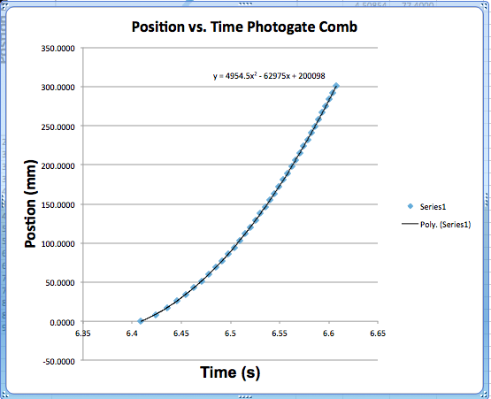

1. Data Tables

**Ball Drop** Manipulated Data

|  |  |  |  |
| --- | --- | --- | --- |
| **Trial** | **Spacing Between Photogates $d$ (cm)** | **Photogate to impact sensor $D$ (cm)** | **Measured acceleration $g$ (m/s2)** |
| 1  2  3  4  5  AVG | $8.5±0.5$ $8.5±0.5$ $8.5±0.5$ $8.5±0.5$ $8.5±0.5$ | $25.5±0.5$ $35.3±0.5$ $42.5±0.5$ $52.0±0.5$ $60.0±0.5$ | $9.3±0.26$ $9.9±0.34$ $9.8±0.46$ $9.9±0.16$ $10.0±0.36$ $9.78±0.32$ |

**Ball Drop** Systematic Uncertainty

|  |  |
| --- | --- |
| **Photogate to impact sensor $D$ (cm)** | **Calculated Systematic Uncertainty in $g$ (m/s2)** |
| $25.5±0.5$ $35.3±0.5$ $42.5±0.5$ $52.0±0.5$ $60.0±0.5$ | $±0.06$ $±0.04$ $±0.06$ $±0.06$ $±0.06$ |

To calculate the Systematic Uncertainty, plug the upper and lower limits for d and D into the derived gravity equation. To find the systematic contribution of δg take (gmax − gmin)/2 for each value of D.

**Upper Limits of Displacements: Lower Limits of Displacements:**

d = dbest +δd d = dbest −δd

D = Dbest +δD D = Dbest −δD

**Ball Drop** Statistical Uncertainty

|  |  |
| --- | --- |
| **Photogate to impact sensor $D$ (cm)** | **Calculated Statistical Uncertainty in $g$ (m/s2)** |
| $25.5±0.5$ $35.3±0.5$ $42.5±0.5$ $52.0±0.5$ $60.0±0.5$ | $±0.2$ $±0.3$ $±0.4$ $±0.1$ $±0.3$ |

The calculation for Statistical Uncertainty is more straightforward than compared to the calculation for Systematic Uncertainty. Plug the data into the given formula:

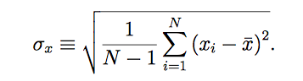

**Briefly describe your uncertainty analysis and whether the uncertainty is dominated by statistical or systematic uncertainties.**

The uncertainty is dominated by the Statistical Uncertainties for the ball Drop Method.

**Photogate** **Comb** Manipulated Data

|  |  |
| --- | --- |
| **Trial Number** | **Measured acceleration $g$**  **(m/s2)** |
| 1  2  3  4  5  Average | $9.908±0.011$ $9.950±0.008$ $9.920±0.011$ $9.990±0.014$ $9.934±0.013$ $9.951±0.012$ |

**Photogate Comb** Systematic Uncertainty

|  |  |
| --- | --- |
| **Trial Number** | **Calculated Systematic Uncertainty in $g$ (m/s2)** |
| 1  2  3  4  5 | $±0.007$ $±0.006$ $±0.007$ $±0.006$ $±0.007$ |

To calculate the Systematic Uncertainty, plug the upper and lower limits for d and D into the derived gravity equation. To find the systematic contribution of δg take (gmax − gmin)/2 for each value of D.

**Upper Limits of Displacements: Lower Limits of Displacements:**

d = dbest +δd d = dbest −δd

D = Dbest +δD D = Dbest −δD

**Photogate Comb** Statistical Uncertainty

|  |  |
| --- | --- |
| **Trial Number** | **Calculated Statistical Uncertainty in $g$ (m/s2)** |
| 1  2  3  4  5 | $±0.004$ $±0.002$ $±0.004$ $±0.008$ $±0.006$ |

The calculation for Statistical Uncertainty is more straightforward than compared to the calculation for Systematic Uncertainty. Plug the data into the given formula:



**Briefly describe your uncertainty analysis and whether the uncertainty is dominated by statistical or systematic uncertainties.**

The uncertainty is dominated by the Systematic Uncertainties for the Photogate Comb Method.

1. Conclusion

The ball-drop experiment took into account both the systematic and the statistical uncertainties. Taking into account error is very important because there was not a perfect system for the lab. Sources of systematic uncertainty include: inaccurate measurements of distances (d and D), air resistance against the falling object, inaccurate equipment (not calibrated correctly), etc. On the other hand, statistical uncertainties arise from the fact that even if the object had been dropped under the exact same conditions, over multiple trials, there is a possibility of the times to be slightly different. As seen in the tables of uncertainties previously shown, the magnitude of statistical errors was much greater than that of systematic errors.

The final calculated acceleration of gravity (g) from the experiment was $9.78±0.32$. The value that was calculated from the experiment is extremely close to the assumed magnitude of gravity, which is about go ≡ 9.80665 $m/s^{2}$. The reason for such an accurate measurement of gravity with varying displacements is because the acceleration is not dependent on the height of the object being dropped. As outlined in the plot depicted earlier, the slope of the trendline was essentially zero, which indicated a constant acceleration over time. This is due to the fact that acceleration is the measure of change in velocity, and the slope of the velocity is equivalent to instantaneous rate of change at any given point.

The Photogate Comb method seems to be the most precise way to set up the experiment based on the data and based on my general observations. Though both methods end up with extremely close values to the expected g, the Comb method shows better results. Firstly, the g values received from the Comb method returned with uncertainty in the hundredths place, whereas the Ball drop method returned with uncertainty in the tenths place. This shows low variance and very high precision. Accuracy-wise, both are comparable, but the Ball Drop Method slightly outbeats the Comb method by a hundredth of a decimal, which is quite insignificant in the big picture.

Lastly, calculating both uncertainties is advantageous because, when both magnitudes are added together they create a larger range of values. A larger range of values helps to guarantee that the actual value of g will lie somewhere in between the range of uncertainties.

**Presentation Mini-Report:**

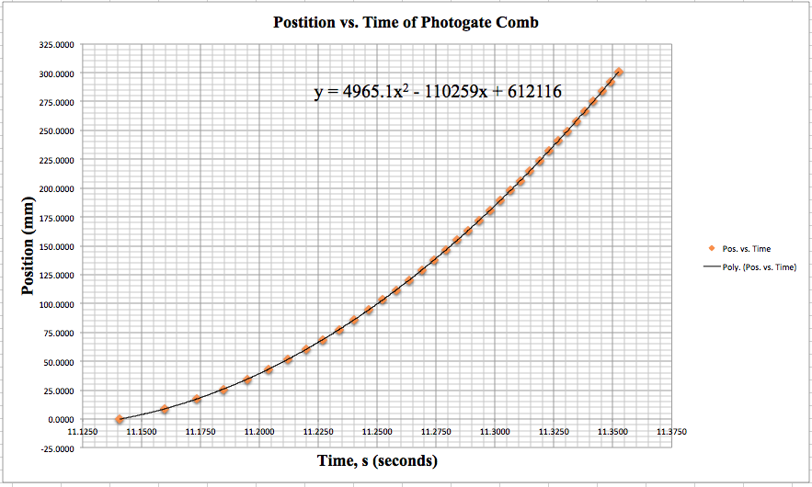

**Analyzing the Quadratic Regression of the Position vs. Time of the Photogate Comb data.** The figure above illustrates time as a function of position. Each point on the figure above represents each slot of the photogate comb that passed through the photogate sensor at a given time. Each moment that a slot passed through the sensor was recorded. The Line of Best Fit is a second degree (quadratic) curve, and the slope of the line represents the acceleration at any given point along the curve. The equation of The Line of Best Fit is located above the curve so that gravity can be calculated.

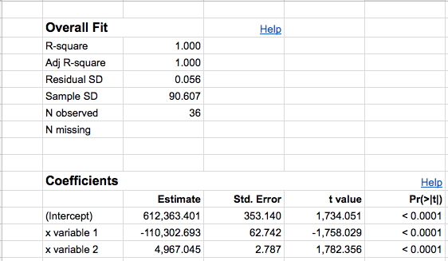

**Figure 1.2 Raw and manipulated data from the Photogate Comb regression.** The main values of importance from this figure is the values of the Estimate and of the Std. Error of “X Variable 2”. The Estimate of X Variable 2 represents the “A” value of a quadratic equation. The Std. Error of “X Variable 2” shows the statistical uncertainty of the “A” value. Similarly, “X Variable 1” shows the “B” of a quadratic equation and “Intercept” shows the “C” value.

The graph shown in **Figure 1.1** is the original Position vs. Time graph with a 2nd degree, quadratic, regression fit to the data. From **Figure 1.2** we get the values for the “X Variable 1”, “X Variable 2”, and “Intercept”, which are the “A”, “B”, and “C” (respectively) from the standard quadratic equation $y=Ax^{2}+Bx+C$.The form of the quadratic equation can also be seen on the upper right side of **Figure 1.1**. However, before we start plugging values into our quadratic equation, it is important to convert our position measurements of millimeters to meters. The reason this is important is because acceleration has units of $m/s^{2}$, and conventional gravity is measured at $9.8 m/s^{2}$. The resulting regression is $y=4.967x{}^{2}-110x+612$. It is important to remember the constant acceleration kinematic equation (Displacement $=\frac{1}{2}at^{2}+v{}_{i}t+d{}_{i}$), this relationship will prove very useful. Using the quadratic equation that we just now calculated, we now know that the “A” value of the quadratic equation equivalent to half of the acceleration, ( $A=\frac{1}{2}a)$ also known as g. In order to find g, all we need to do is multiply “A” by 2. In this case, $4.967⋅2=9.934$, which is the value for g. To cross-check the calculated value of g = 9.934 we can do a simple comparison to the actual magnitude of gravity, which is go ≡ 9.80665 $m/s^{2}$; 9.934 is quite close to the actual value. Another important note is that, in this case, “B” and “C” do not have an effect on the final value of gravity, but it is good to know where the values are derived from.

**Figure 1.1 Word Count:** 100

**Figure 1.2 Word Count:** 86

**Paragraph Word Count:** 300

Bibliography:

1. Campbell, W. C. et al. Physics 4AL: Mechanics Lab Manual (ver. August 31, 2017). (Univ. California Los Angeles, Los Angeles, California).